Members: Ramzi Adil, James Ouk, Jeicy El Hajj, Jack Hester

Team 31

CS5520 Spring 2022

# P2 Project Design Assignment

***2. Introduce your app in a few sentences. This can be pulled from your proposal.***

**Description:**

Make isometric exercises easier. Less counting, more rep’ing. Stay Balanced helps you maintain your form and counts how many seconds you are in it. It also counts how many sets you’ve done each day. See yourself transform in a few weeks and build your strength and endurance.

Features:

* Watch yourself improve over time with a chart that tracks your progress
* Never worry about looking at your phone while exercising with audio cues
* Structure your workouts with reminders and streaks
* Complete challenges to unlock new rewards

Requirements:

* Phone strap accessory
* Device with a gyroscope

3. List the screens (activities) that will be used in your app. Just list them. For example: "Location display" or "list of links to choose".

* Home screen
* Workout history
* Exercise selection screen
* Calibration screen
* Settings menu

4. Mark one or more screens that are central to the functionality, which we will be testing this week. We will call these the chosen screens (even if there is just one chosen screen, this document will refer to them as the chosen screens).

* Home Screen
* Calibration screen

***4a. Describe your target users. This may be the same as what you submitted in your proposal, in which case you can copy and paste that description. (Don't write "see proposal.")***

This app will be targeting people at a high school age or older who are familiar with exercising and isometric exercises in particular. The target users are people who want to track their physical health progress over time.

***4c. For each chosen screen, make at least two designs in paper prototype. By hand on paper. Paper If you don't understand why I emphasize this, you need to re-read the assigned readings.***

**Home Screens:**

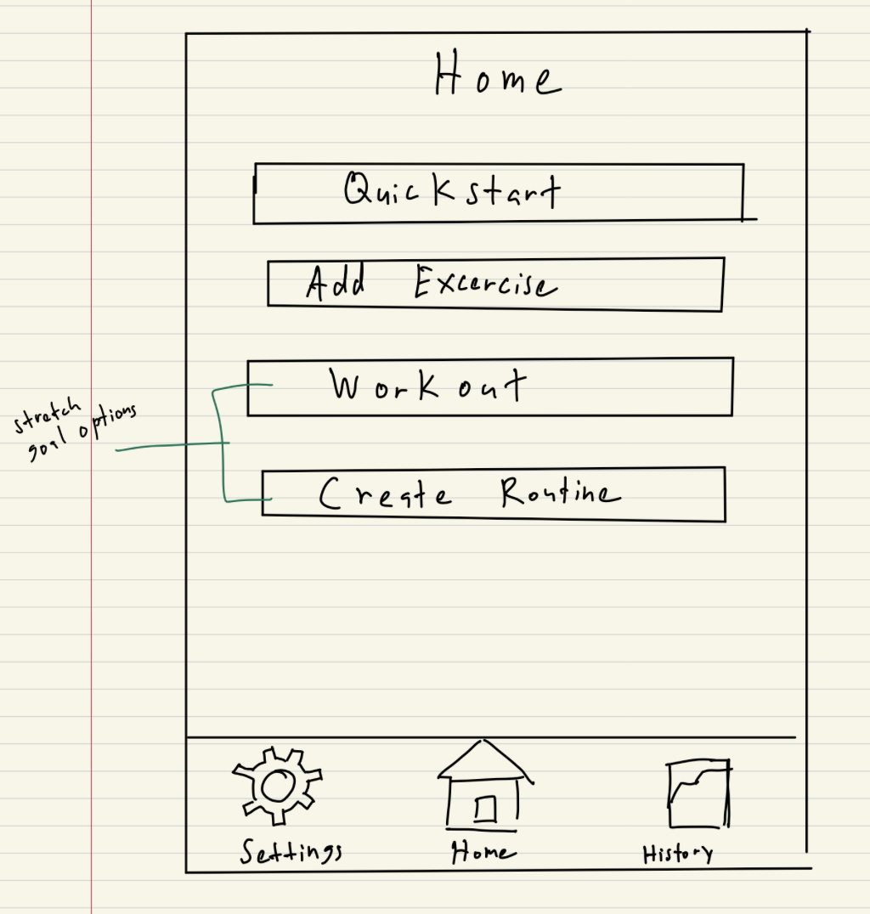

Figure 4.1 home screen 1

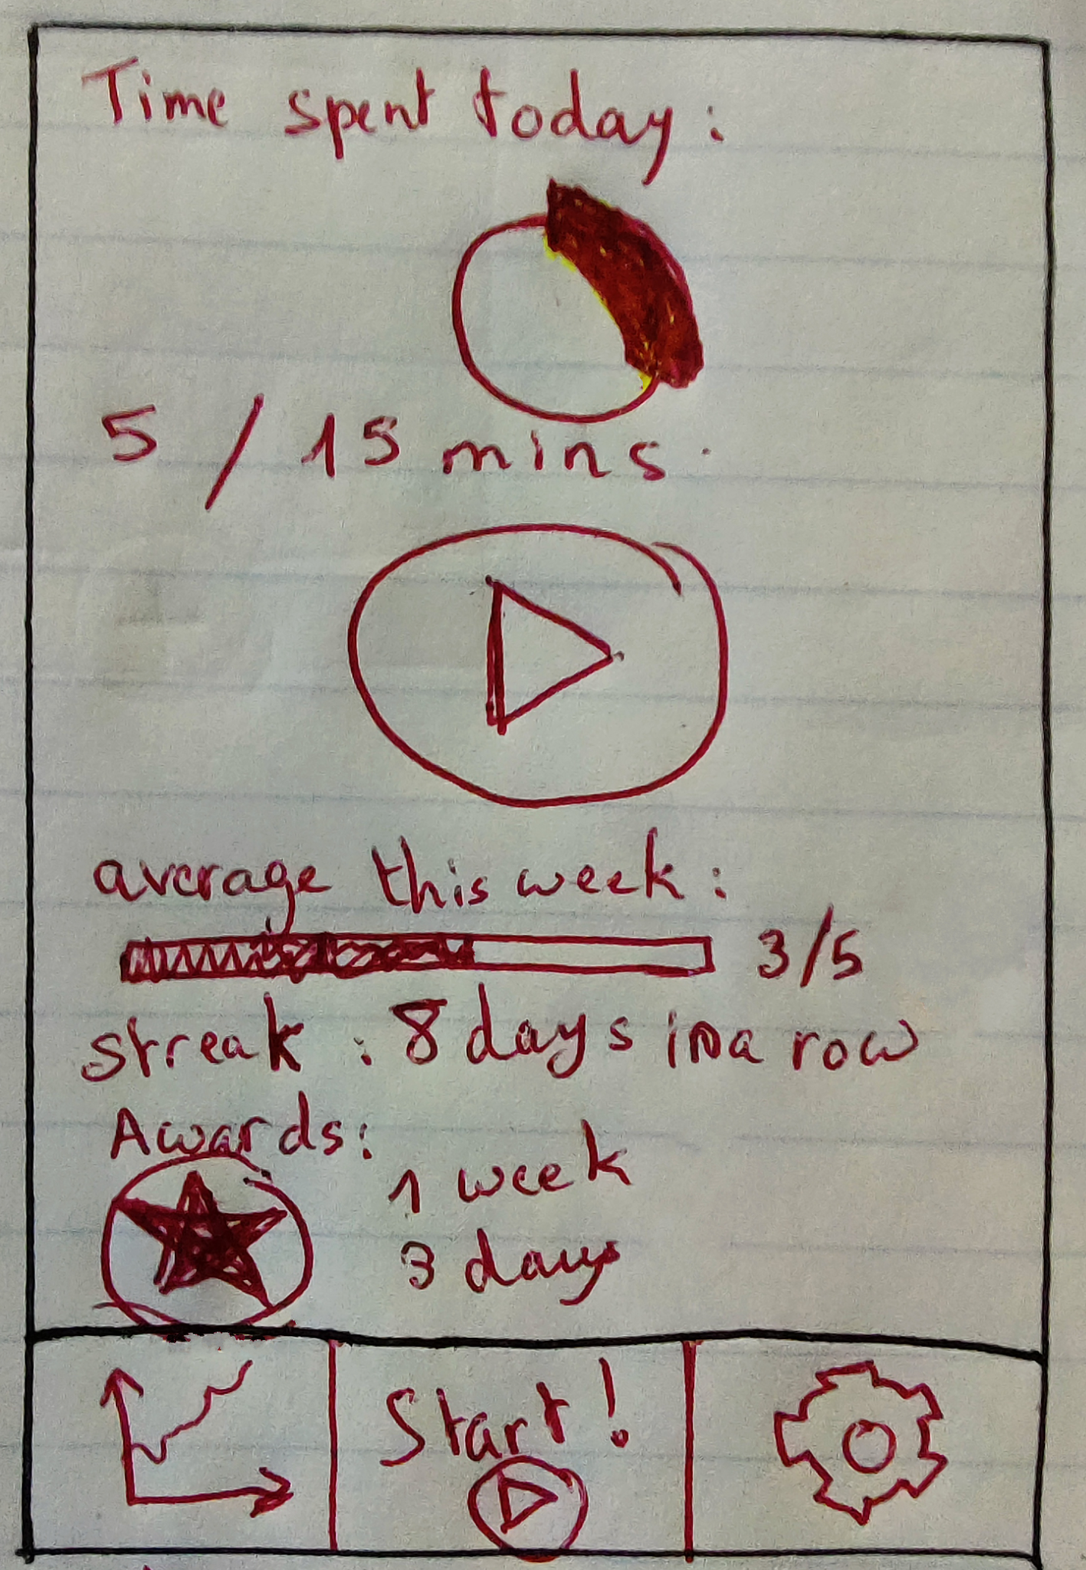  
Figure 4.2 home screen 2

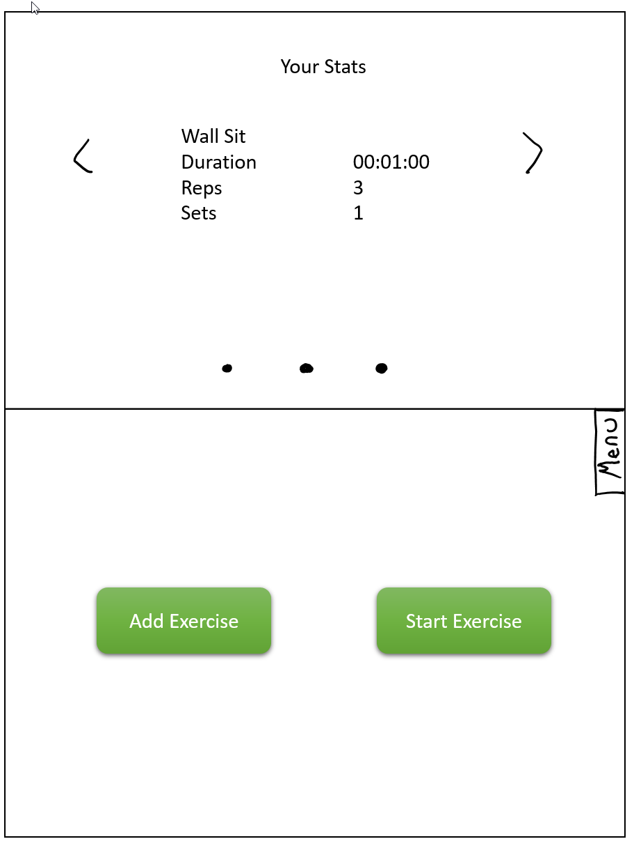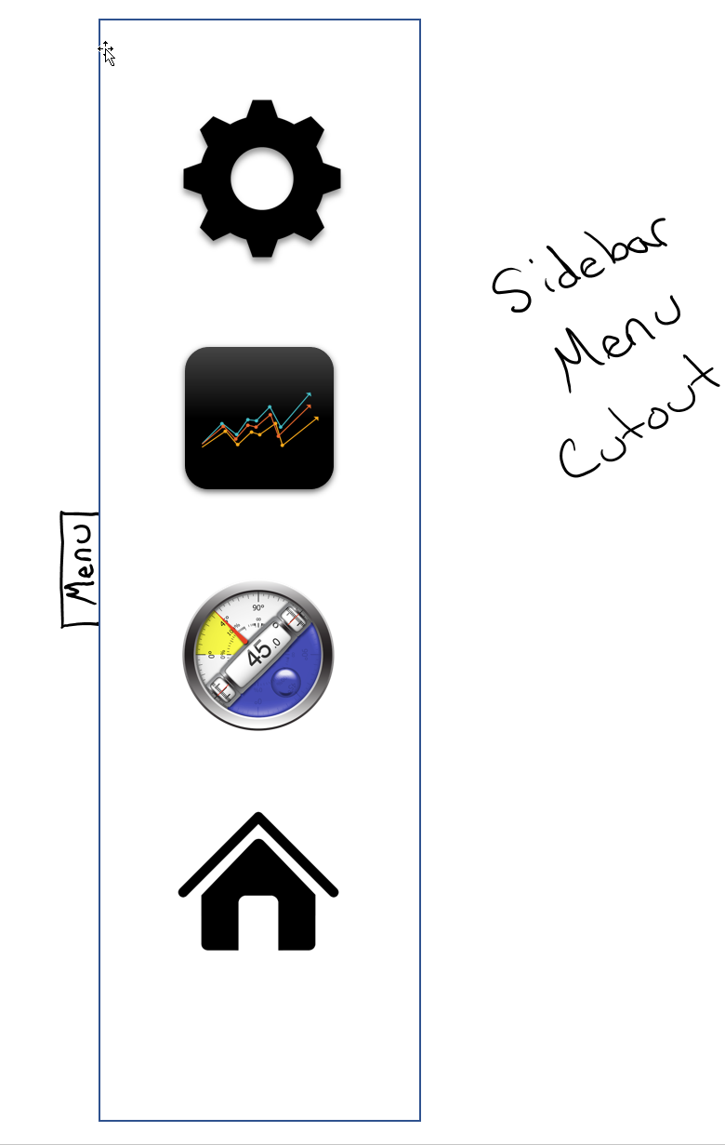

Figure 4.3 home screen 3

**Calibration Screens:**

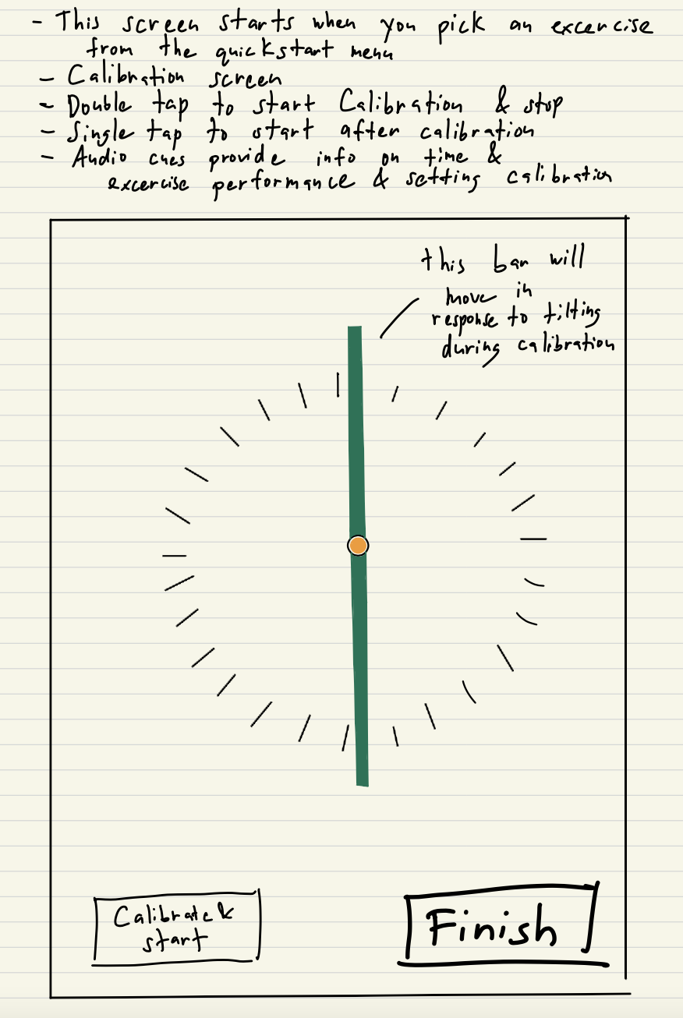

Figure 4.4 calibration screen 1

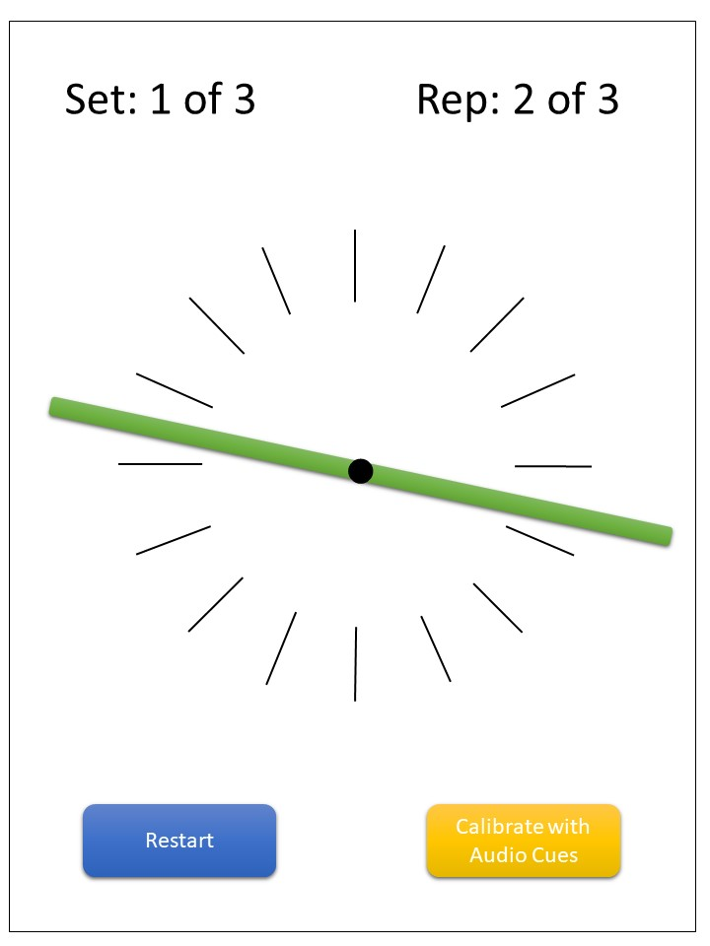

Figure 4.5 calibration screen 2

***4d. For each test user, present the user with the paper prototypes. Include photos of the process of paper prototyping with your potential users. Take at least one photo of the process for each paper prototype, and include these in your assignment submission.***

**Album for paper prototype testing:** <https://photos.app.goo.gl/fq9nCjifmfTb2G4E8>

***4e. For each paper prototype, follow the methodology of user sketches to gather reactive feedback (summarize the feedback in notes) and reflective feedback (sketches from the users and your notes on verbal discussion with the users). Include the notes and sketches in your assignment submission. If you aren't sure what reactive and reflective feedback are, go back and review the readings.***

**User 1 Feedback:**

* The calibration screen is not informative. The user is not sure how to use/interact with this screen. It was recommended that instructions be given upon the start of the calibration screen
* The calibration screen having a finish button was confusing. The user thought it would be better for the exercise to terminate upon completion. Figure 4.5 was the preferred calibration design.
* Having two start buttons seemed repetitive as shown in figure 4.2. Having just one would be more clear as shown in the user’s own sketch of the home screen (Figure 4.6).
* The home screen should show rewards/ streaks/ info that would motivate the user to return to use the app i.e. figure 4.2.
* The bottom bar design (Figure 4.2) was preferred over a sliding menu design figure 4.3).
* The exercise history screens should also show not only total time for each exercise but the proportionate amount of time spent in the correct position. The history screen can further include more info and a drop down bar to select the exercise to track. These suggestions are reflected in the user’s sketch of the history screen (See figure 4.7).

**User 1 Sketches:**

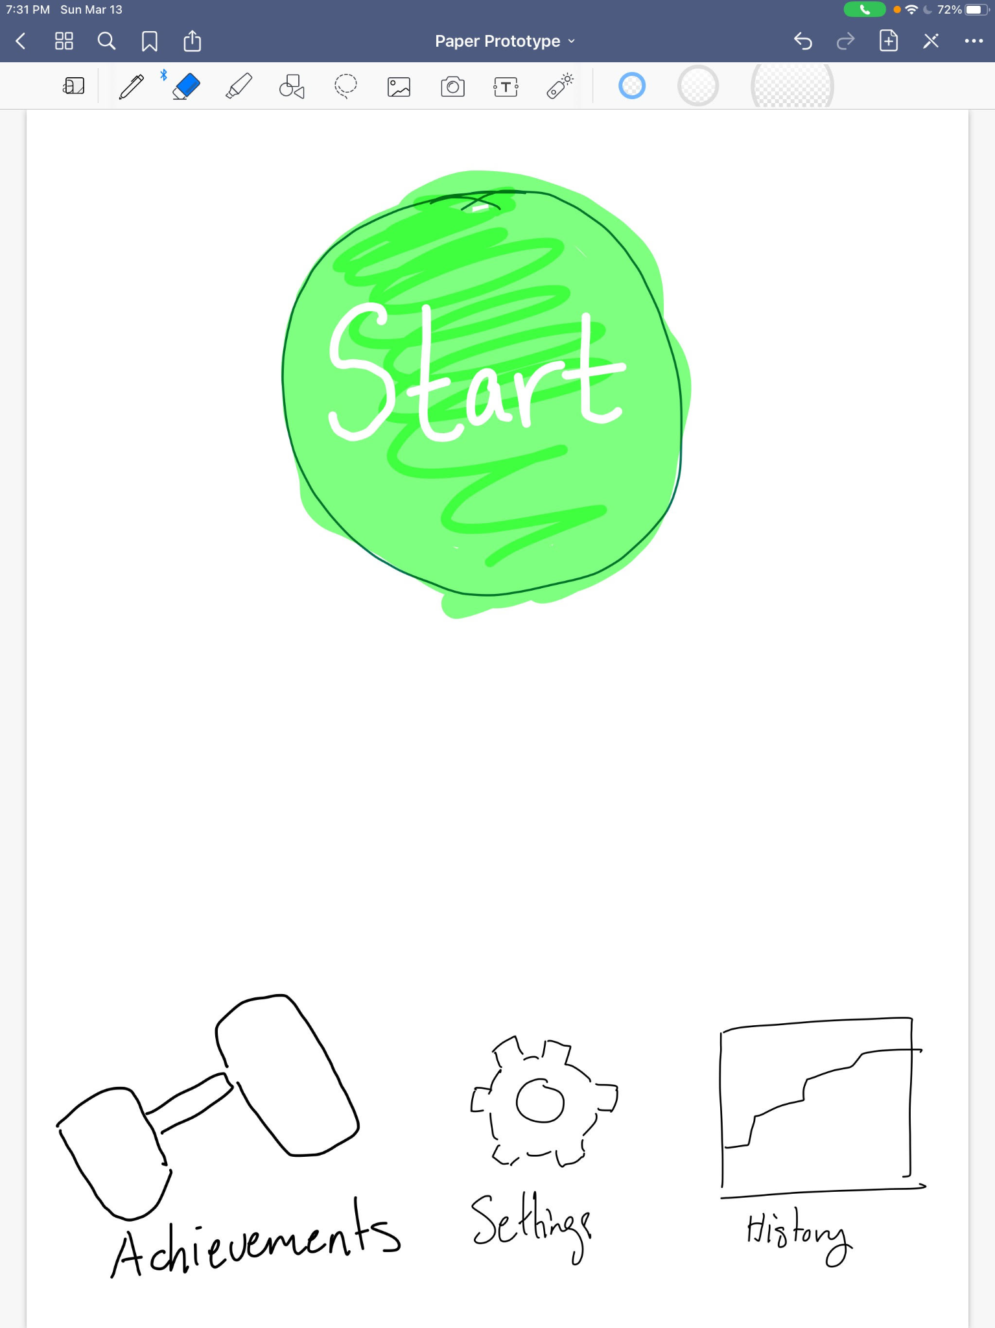 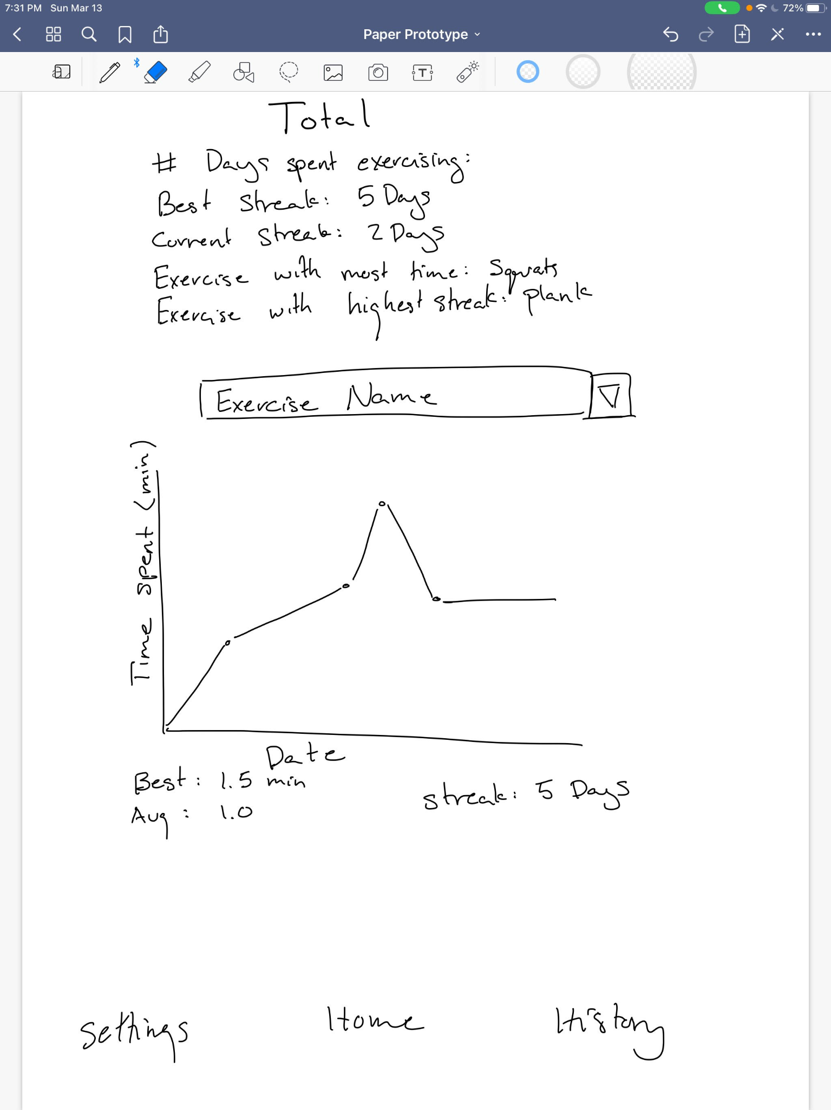

**Figure 4.6. User 1 Sketch Home Screen.** **Figure 4.7 User 1 sketch history**

**User 2 Feedback:**

* Main Screen: Figure 4.1’s button layout was straight forward which they enjoyed but they enjoyed having access to motivation from figure 4.2.
* Figure 4.2’s dual start workout buttons did not make sense to them.
* They did not like the empty space that was in the 4.1 and 4.3 designs and preferred a constant bottom menu design over a side menu.
* Calibration screen: Didn’t enjoy the double tap to calibrate feature which was redundant to them considering there’s a button to calibrate.
* Preferred the layout in 4.5 with more buttons and rep information in the design. They needed more instructions and were asking for how to and general instructions which is what they wanted to portray most in their design.
* In the user’s sketches they wanted to highlight a menu at the bottom where they could see their awards and history and how close they are to their next milestone as well as clear buttons to get to the workout section of the app. They liked the scrollable design and wanted to integrate it with a highlight of the awards tab. They also wanted to see the previous day’s workout to see what to focus on today: if they were working on arms yesterday they can focus on legs today for example. The calibration screen they wanted to add instructions to in their sketches and the name of the workout.

**User 2 Sketches:**

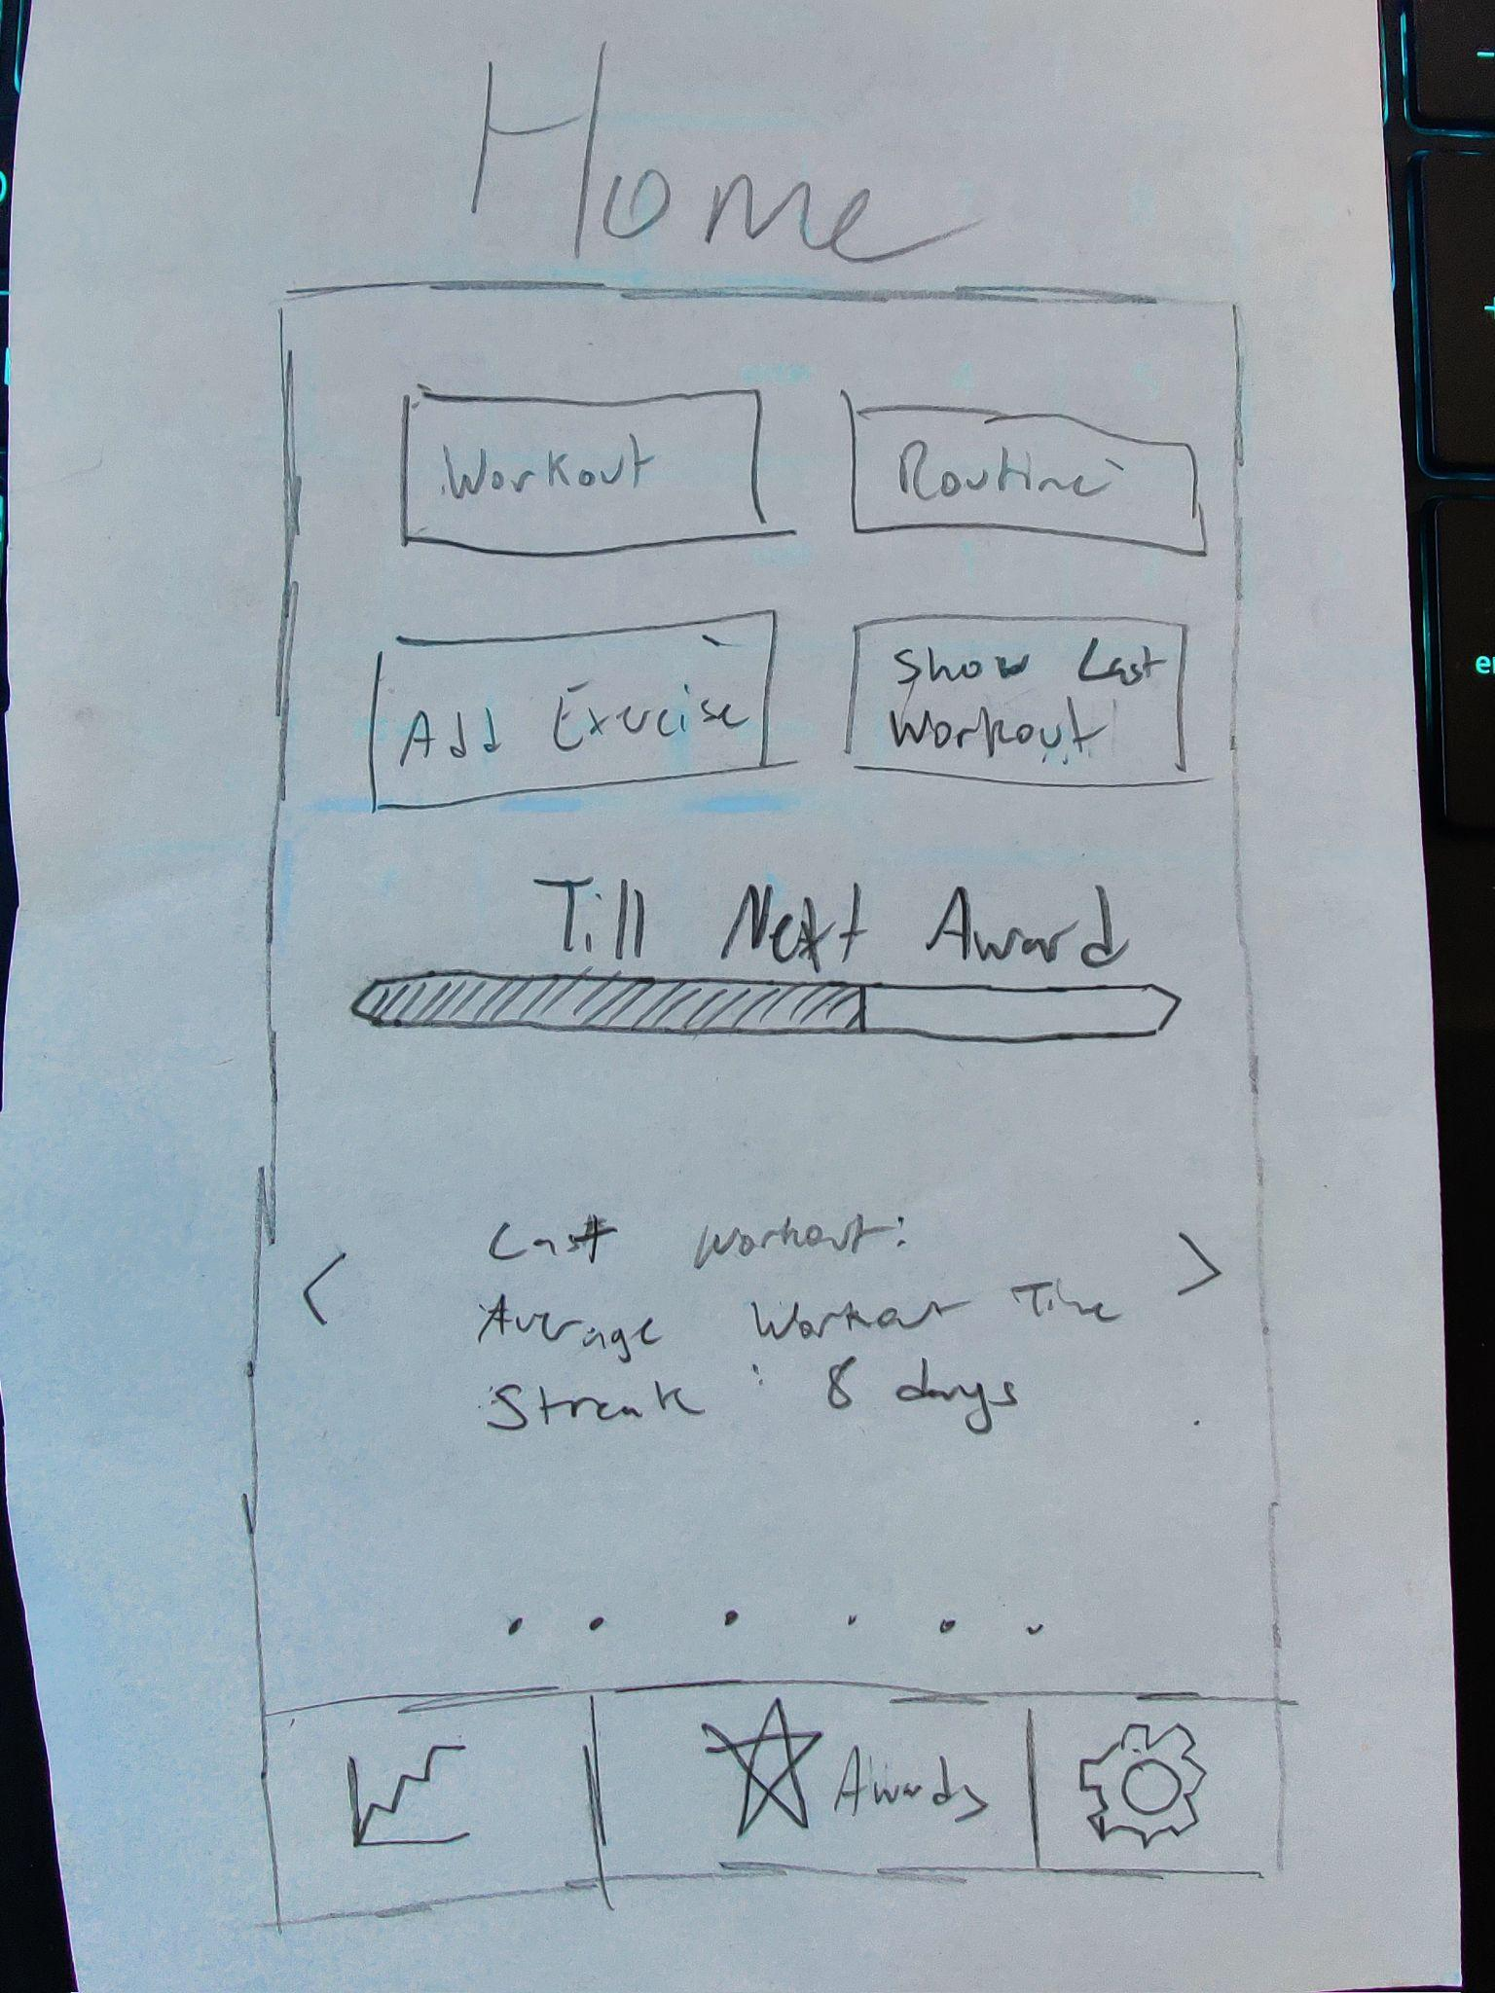

**Figure 4.8 User 2 home screen sketch**

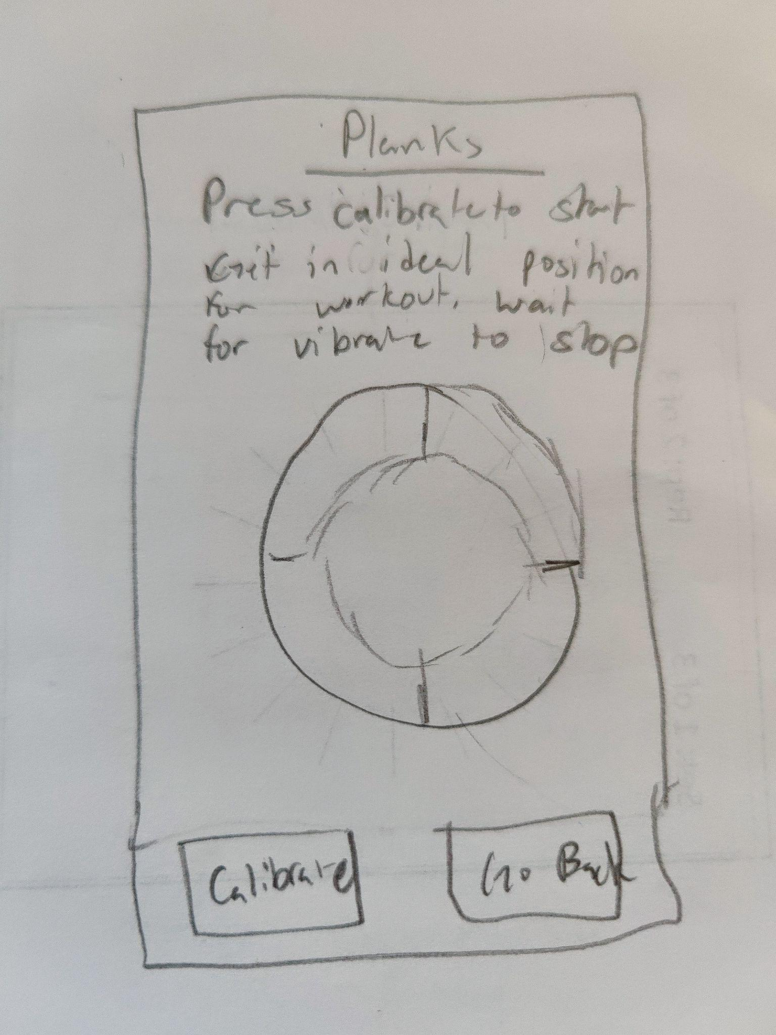

**Figure 4.9 User 2 calibration screen sketch**

***5. Design the chosen screens based on the feedback, and include the design in your assignment submission. Each screen design will be an image (computer drawn or hand-sketched) and possibly description of interaction that cannot be seen from the image. For this assignment, you are designing only the chosen screens, but teams are encouraged to start working on designs for the other screens.***

**Screens Designed Based On Feedback:**

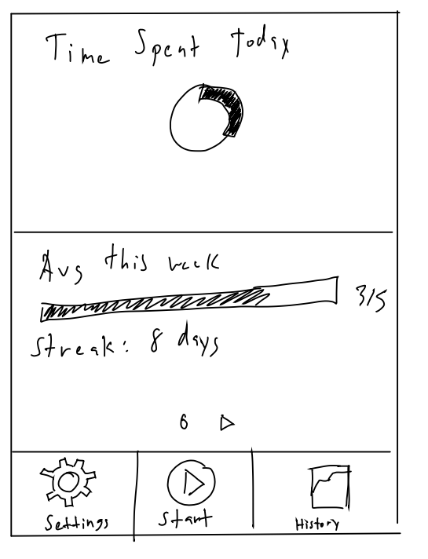

**Figure 5.1 Home Screen.** This is the screen that will show up when the app has been selected. We plan to have the motivational Images/Views/Displays that the user can scroll through horizontally, as that was a feature our testers liked.

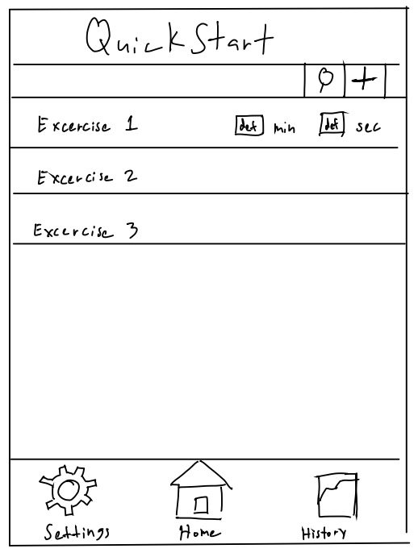

**Figure 5.2 The exercise selection screen.** The screen will show up when the user has clicked the start button. It has a list of saved/pre-built exercises as well as an add exercise button and search. ( The home icon and home button will be replaced with the start design shown in the bar of Figure 5.1 )



**Figure 5.3 Calibration Screen.** This screen will pop up once the user selects an exercise from the exercise selection screen shown in Figure 5.2. Testers commented they weren’t sure how this screen worked when they opened it up. We will address this by implementing tutorials of some kind to introduce them to it. We may have tooltips pop up. We plan to take advantage of the gestures Android mobile apps have available to them on this screen (taps and swipes)

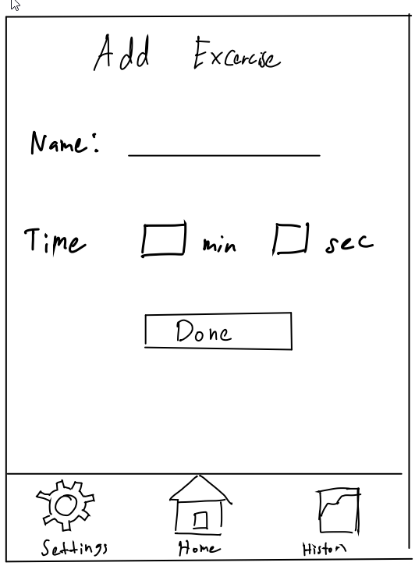

**Figure 5.4 Add exercise screen.** This screen will appear when the user has clicked the “add exercise” button (plus symbol) shown in the exercise selection screen (Figure 5.2)

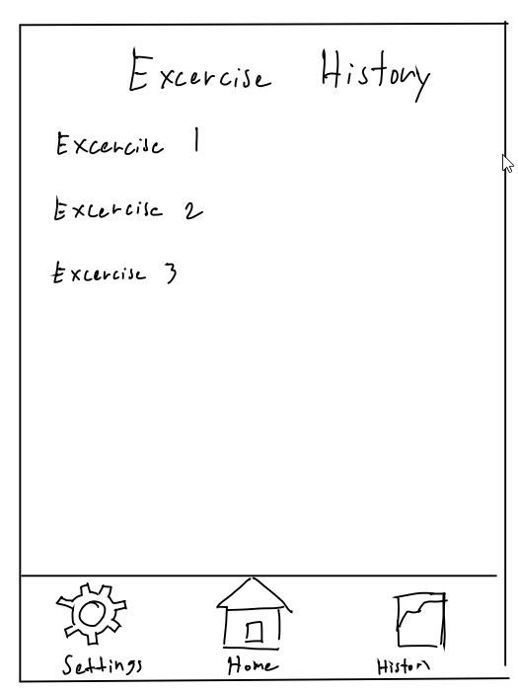**Figure 5.5 Exercise History Selection Screen.** The user will select an exercise they want to look at the history of.

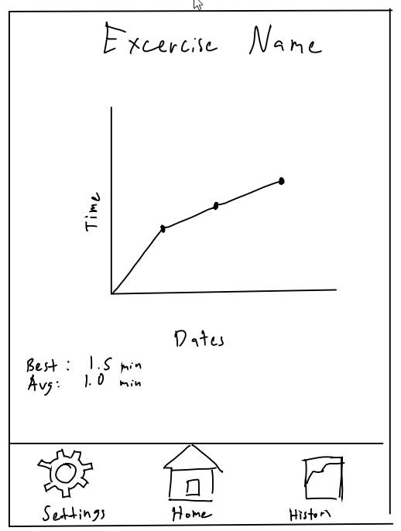**Figure 5.6 Exercise history screen.** This will show up after an exercise has been chosen from the exercise history screen (figure 5.5)